HW6

20184448 조민기

Prob 1

1)

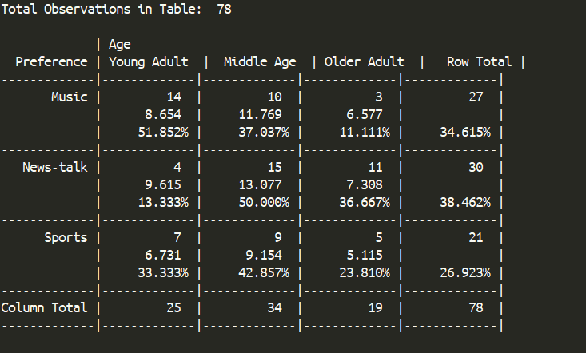

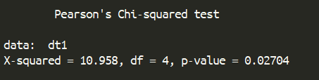

The P-value is less than 0.05. Therefore, the null hypothesis that the preference does not differ by age group is rejected.

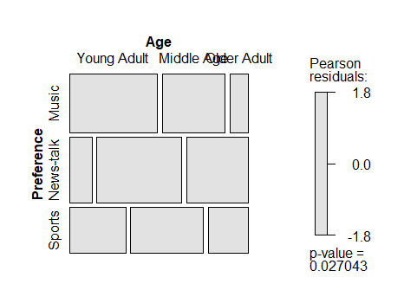  
  
Prob 2

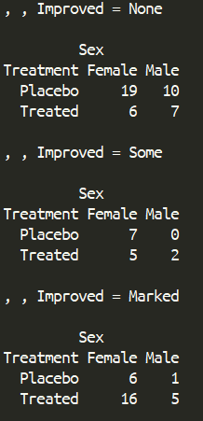

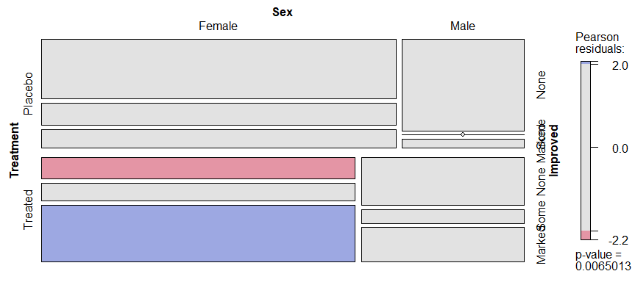

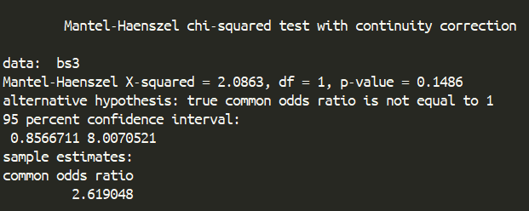  
P-value > 0.05. The null hypothesis is rejected which means the nominal variable is dependent to the improved.

